**Online Test Application**

**Developer Name: PUTTA SAI KUMAR**

This document contains contents for:

* Project Description
* Sprint planning
* Flow of the Application
* Core concepts used in project
* Conclusions

**1.Project Description:**

* The Online Test Application system creates an application that enables users to provide online tests, review them, and display the results.
* This system contains three main modules: Quiz, Review, and Result. The quiz section of the online test application accepts the questions in JSON format.
* The JSON file can be easily shared from the server in the pre-defined format. The application renders the test at the client-side.  
  The “Review and display result” section allows users to declare the results immediately.
* You can simply call another JSON with the answers in it and evaluate and display the results immediately.

**2.Sprints planning:**

The project is planned to be completed in 2 sprints.

Tasks assumed to be completed in the sprint are:

· Creating the flow of the application

· Initializing git repository to track changes as development progresses.

· Writing the Java program to fulfill the requirements of the project.

· Testing the Java program with different kinds of User input

· Pushing code to GitHub

· Creating this specification document highlighting application capabilities, appearance, and user interactions.

**3.Application Flow:**

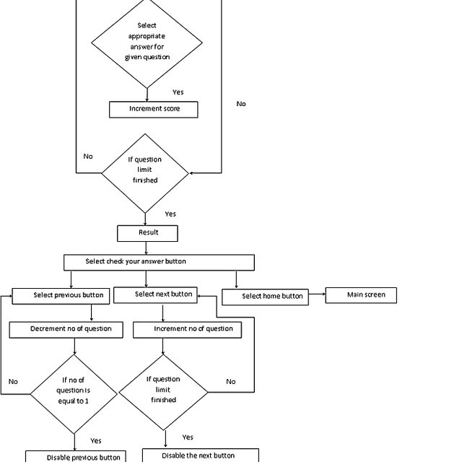

**4.Core concepts used in project:**

* Html
* CSS
* Angular
* Boot strap
* JSON

**5.Conclusions:**

This project is designed to create a online test application in JSON Format using angular/bootstrap.